IT 214 – Section 009

ANDREA PEREZ ISLA

G01169101

Homework 9

11/07/18

**PREMIERE PRODUCTS**

13. List the order number and order date for each order placed by the customer named Johnson’s Department Store.

SELECT ORDER_NUM,ORDER_DATE FROM ORDERS WHERE CUSTOMER_NUM IN (SELECT CUSTOMER_NUM FROM CUSTOMER WHERE CUSTOMER_NAME=”Johnson’s Department Store”);

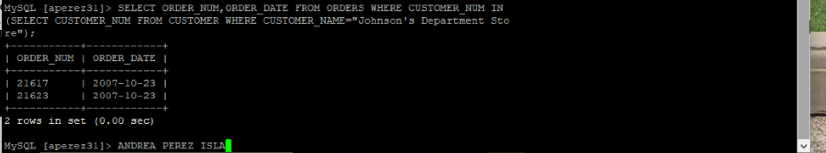

15. List the order number and order date for each order that either was placed by Johnson’s Department Store or that contains an order line for a Gas Range.

SELECT ORDER_NUM,ORDER_DATE FROM ORDERS WHERE CUSTOMER_NUM IN (SELECT CUSTOMER_NUM FROM CUSTOMER WHERE CUSTOMER_NAME=”Johnson’s Department Store”) UNION SELECT ORDER_NUM, ORDER_DATE FROM ORDERS WHERE ORDER_NUM IN (SELECT ORDER_NUM FROM ORDER_LINE WHERE PART_NUM IN (SELECT PART_NUM FROM PART WHERE DESCRIPTION=”Gas Range”));

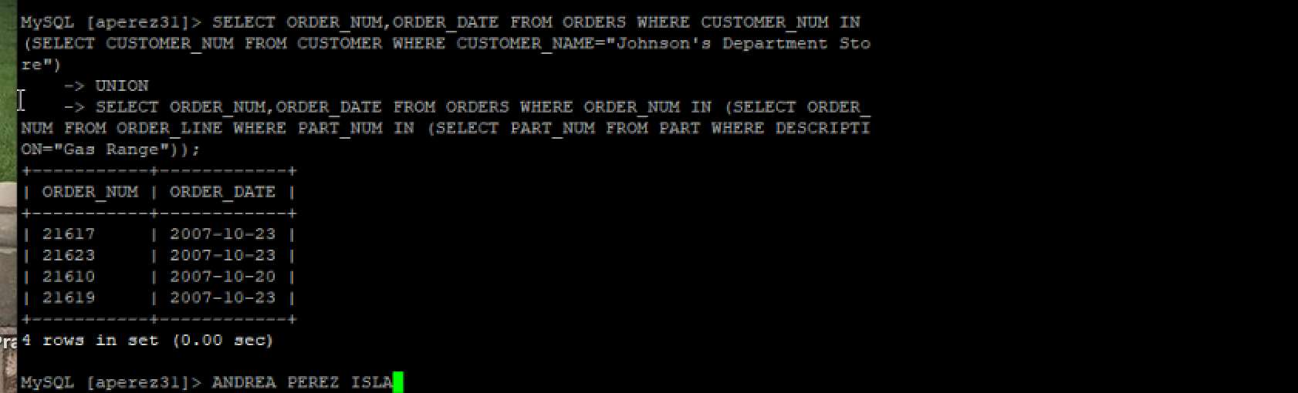

7. For each order, list the order number, order date, part number, part description, and item class for each part that makes up the order.

SELECT ORDERS.ORDER_NUM, ORDER_DATE, PART.PART_NUM, DESCRIPTION, CLASS   
FROM ORDERS, ORDER_LINE, PART  WHERE ORDERS.ORDER_NUM = ORDER_LINE.ORDER_NUM  AND ORDER_LINE.PART_NUM = PART.PART_NUM

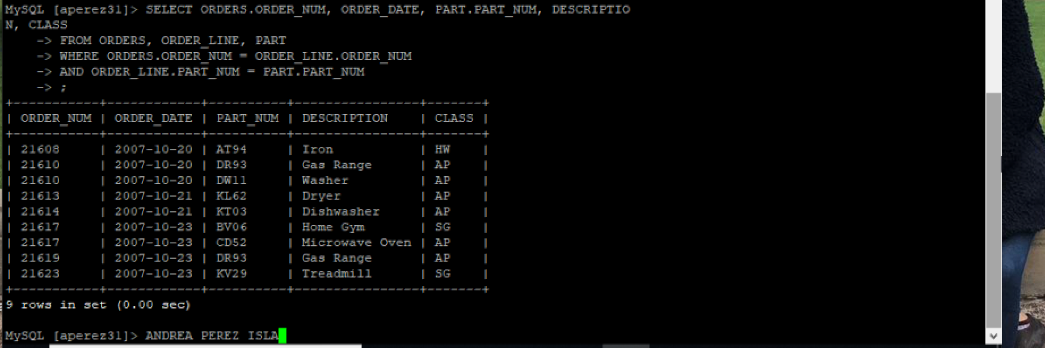

14. List the order number and order date for each order that contains an order line for an Iron.

SELECT ORDER_NUM, ORDER_DATE FROM ORDERS WHERE ORDER_NUM IN (SELECT ORDER_NUM FROM ORDER_LINE WHERE PART_NUM IN (SELECT PART_NUM FROM PART WHERE DESCRIPTION = 'Iron'));

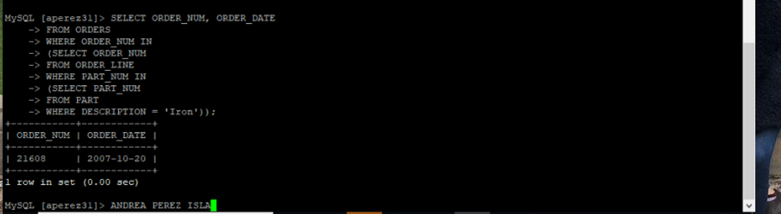

3. For each order, list the order number, order date, part number, number of units ordered, and quoted price for each order line that makes up the order.

SELECT ORDERS.ORDER_NUM, ORDER_DATE, PART.PART_NUM, ORDER_LINE.NUM_ORDERED,QUOTED_PRICE

FROM ORDERS, PART, ORDER_LINE WHERE ORDERS.ORDER_NUM = ORDER_LINE.ORDER_NUM AND ORDER_LINE.PART_NUM = PART.PART_NUM;

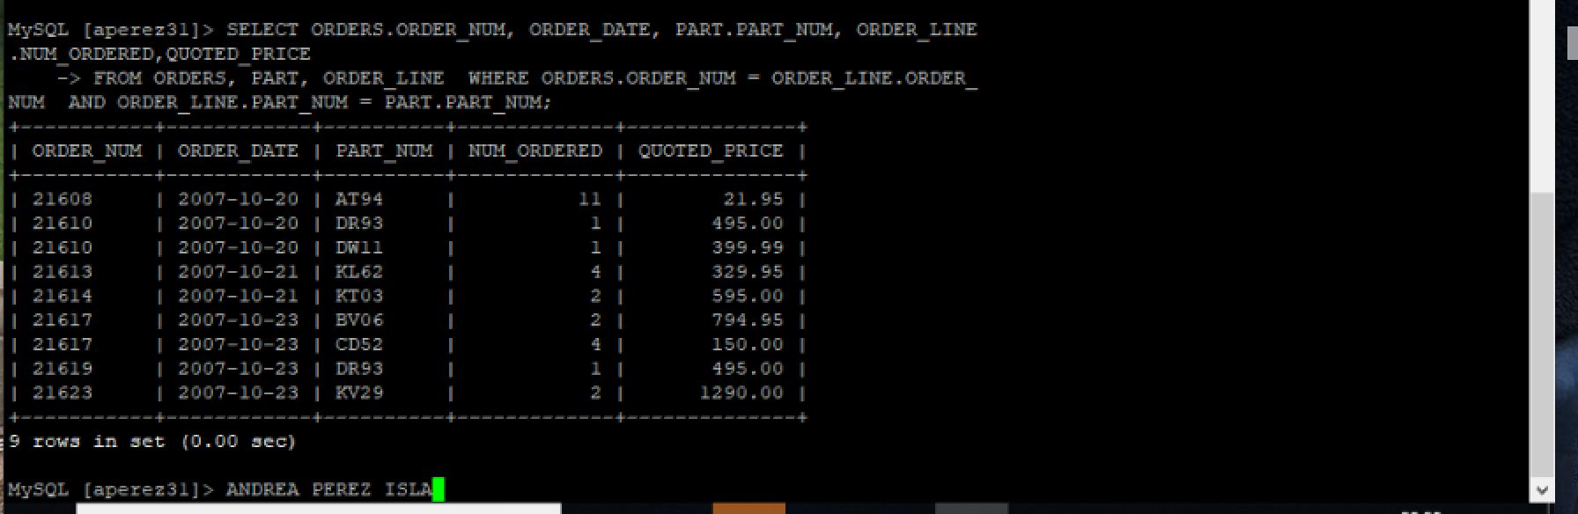

16. List the order number and order date for each order that was place by Johnson’s Department Store and that contains an order line for a Gas Range.

SELECT O.ORDER_NUM, O.ORDER_DATE

FROM ORDERS O

JOIN CUSTOMER C

ON C.CUSTOMER_NUM = O.CUSTOMER_NUM

AND C.CUSTOMER_NAME=”Johnson’s Department Store”

JOIN ORDER_LINE I

ON I.ORDER_NUM = O.ORDER_NUM

AND I.PART_NUM IN (SELECT PART_NUM FROM PART WHERE DESCRIPTION=”Gas Range”);



8. Repeat Exercise 7, but this time order the rows by item class and then by order number.

SELECT ORDERS.ORDER_NUM, ORDER_DATE, PART.PART_NUM, DESCRIPTION, CLASS   
FROM ORDERS, ORDER_LINE, PART   
WHERE ORDERS.ORDER_NUM = ORDER_LINE.ORDER_NUM   
AND ORDER_LINE.PART_NUM = PART.PART_NUM  
ORDER BY PART.CLASS, ORDERS.ORDER_NUM;



**HENRY BOOKS**

10. Find the book title, author last name, and units on hand for each book in branch number 4.

SELECT TITLE,BOOK_CODE FROM BOOK WHERE BOOK_CODE IN (SELECT BOOK_CODE FROM INVENTORY WHERE BRANCH_NUM=’4’);

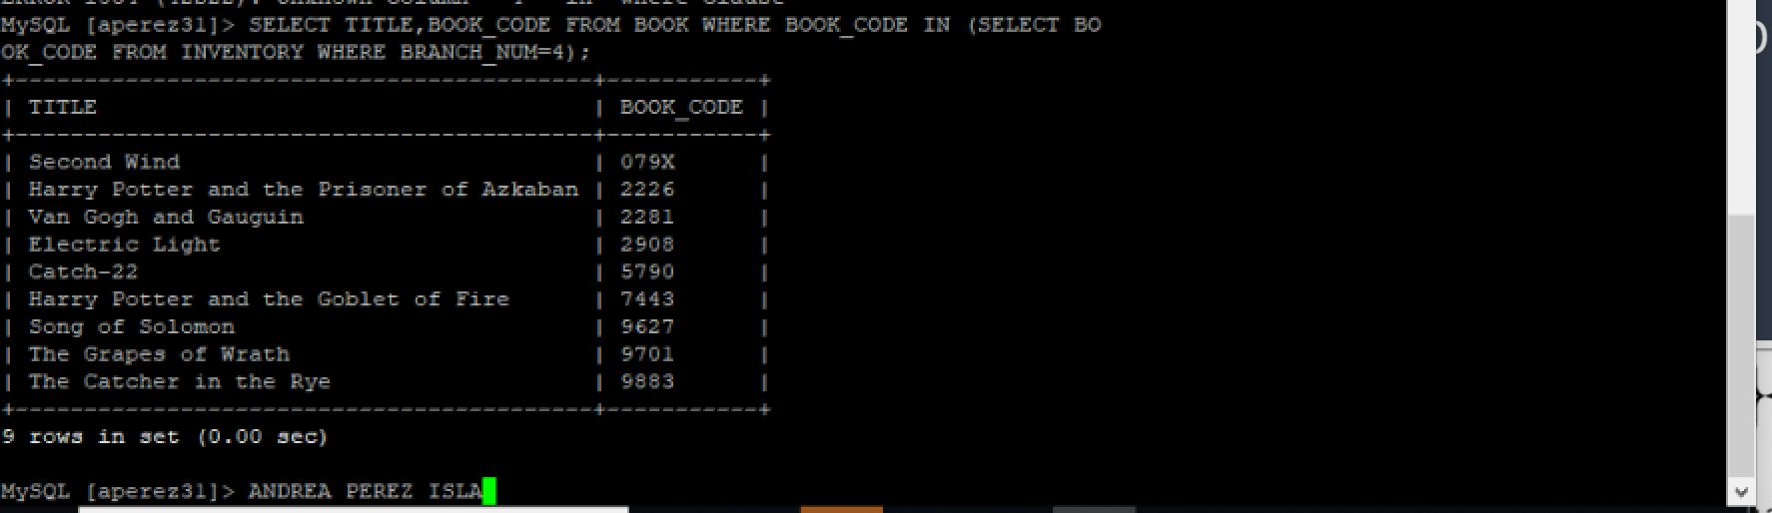

8. Find the book code and book title for each book located in branch number 2 and written by author 20.

SELECT B.BOOK_CODE, B.TITLE

FROM BOOK B

JOIN WROTE W

ON W.BOOK_CODE = B.BOOK_CODE

AND W.AUTHOR_NUM ='20'

JOIN INVENTORY I

on I.BOOK_CODE = B.BOOK_CODE

AND I.BRANCH_NUM ='2'

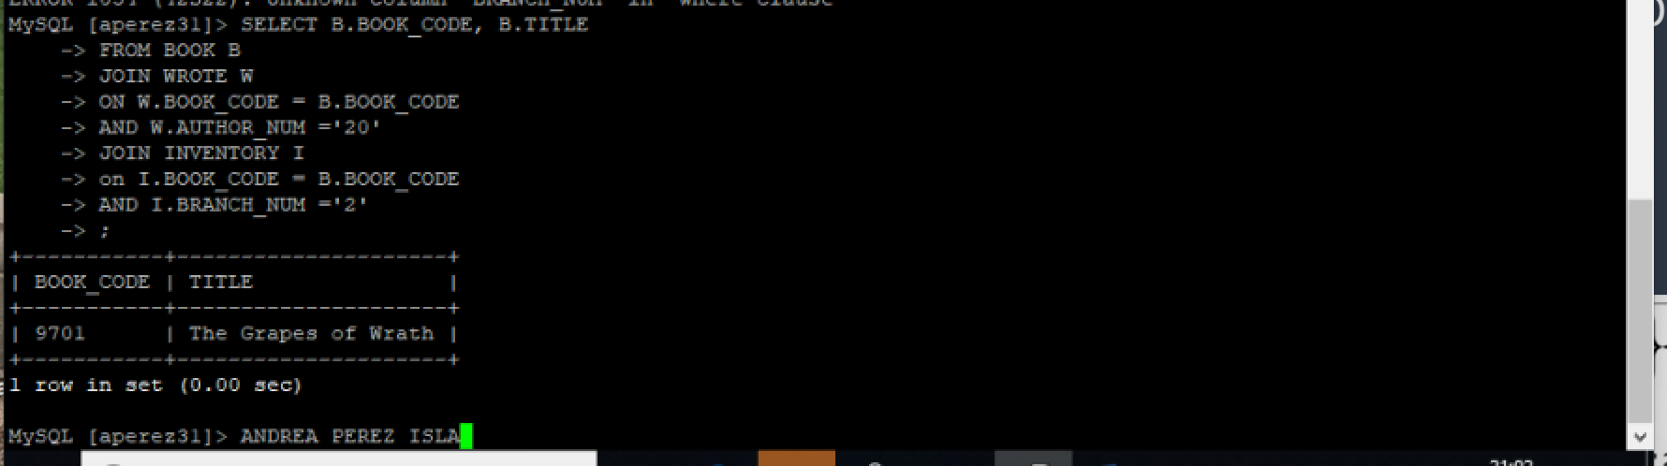

17. List the book code, book title, and units on hand for each book in branch number 2. Be sure each book is included, regardless of whether there are any copies of the book currently on hand in branch 2. Order the output by book code.

SELECT BOOK.BOOK_CODE, BOOK.TITLE, INVENTORY.ON_HAND   
FROM BOOK LEFT JOIN INVENTORY   
ON ( BOOK.BOOK_CODE = INVENTORY.BOOK_CODE AND INVENTORY.BRANCH_NUM = 2 ) ORDER BY BOOK.BOOK_CODE;

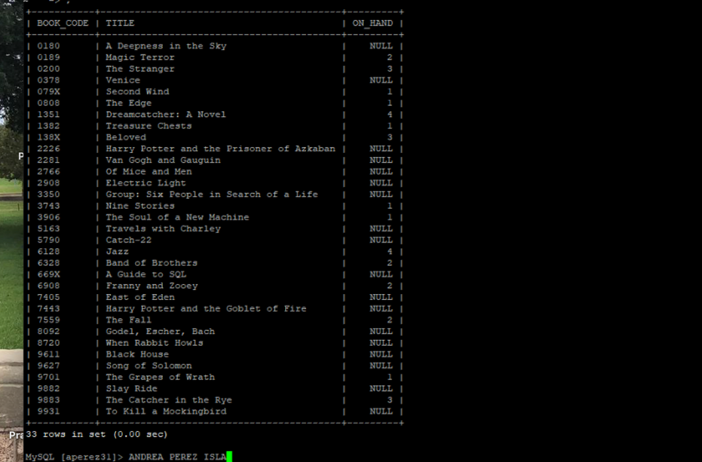

2. For each book published by Plume, list the book code, book title, and price.

SELECT BOOK_CODE,TITLE,PRICE FROM BOOK WHERE PUBLISHER_CODE IN (SELECT PUBLISHER_CODE FROM PUBLISHER WHERE PUBLISHER_NAME=”Plume”);

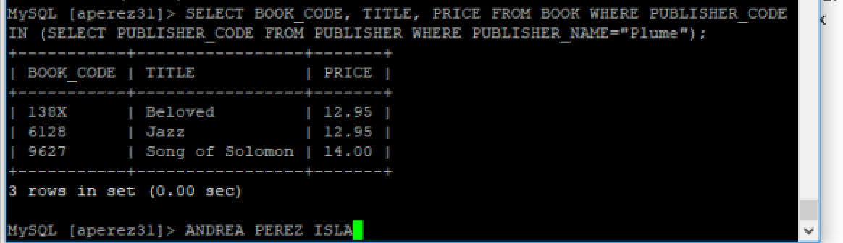

5. List the book title for each book that has the type PSY and that is published by Jove Publications.

SELECT B.TITLE  
FROM BOOK B  
INNER JOIN PUBLISHER P  
ON B.PUBLISHER_CODE = P.PUBLISHER_CODE  
WHERE B.TYPE = 'PSY' AND P.PUBLISHER_NAME ='Jove Publications';

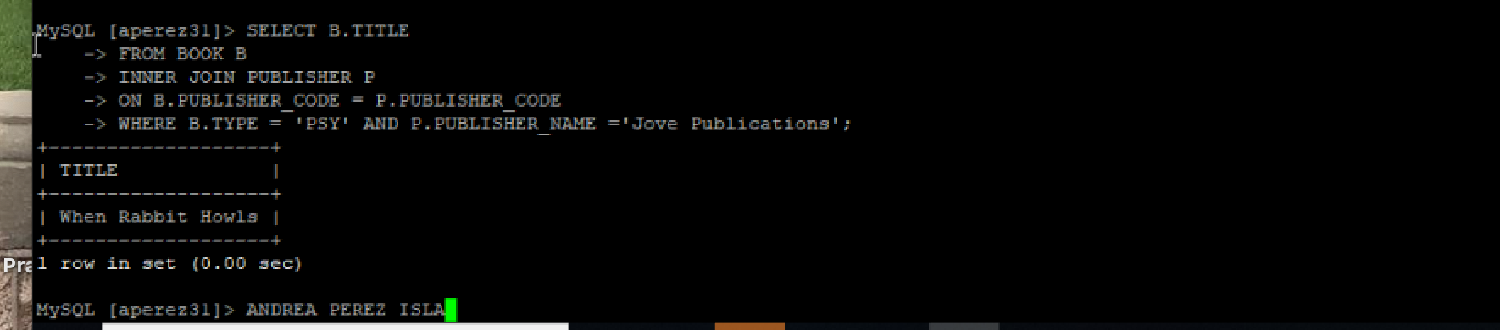

**ALEXAMARA MARINA GROUP**

15. Repeat Exercise 14, but this time be sure each slip is included regardless of whether the boat in the slip currently has any service requests for category 2.

SELECT MS.SLIP_ID, BOAT_NAME, OWNER_NUM, SR.SERVICE_ID, EST_HOURS, SPENT_HOURS   
FROM SERVICE_REQUEST SR   
LEFT JOIN MARINA_SLIP MS  
ON SR.SLIP_ID = MS.SLIP_ID  
WHERE SR.CATEGORY_NUM = 2;

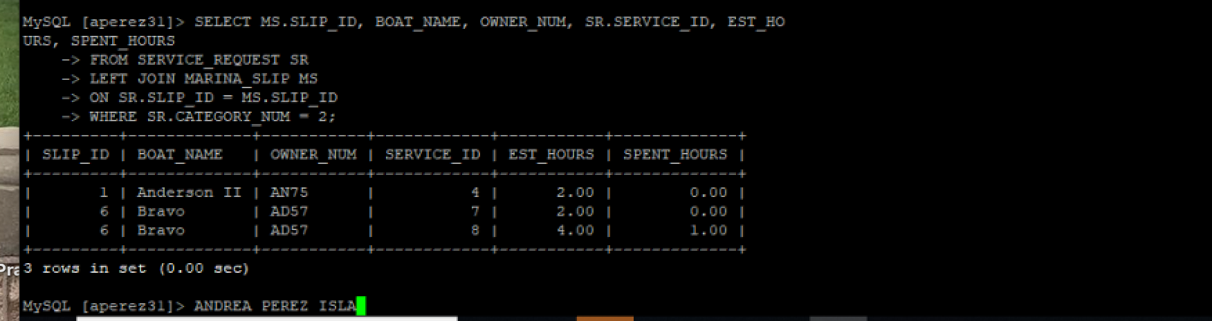

2. For every completed or open service request for routine engine maintenance, list the slip ID, description, and status.

SELECT SLIP_ID,DESCRIPTION,STATUS FROM SERVICE_REQUEST WHERE CATEGORY_NUM IN (SELECT CATEGORY_NUM FROM SERVICE_CATEGORY WHERE CATEGORY_DESCRIPTION=’Routine engine maintenance’);

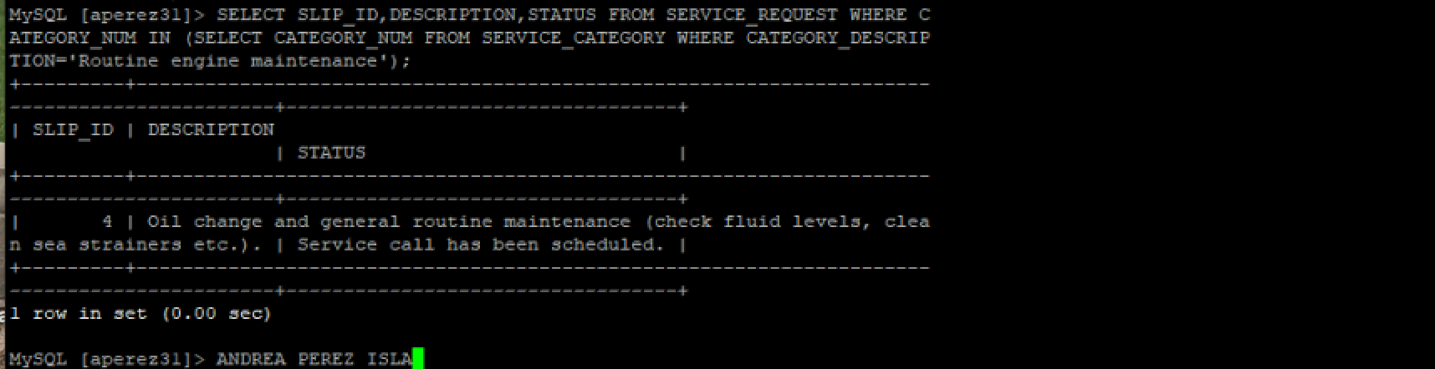

14. List the slip ID, boat name, owner number, service ID, number of estimated hours, and number of spent hours for each service request on which the category number is 2.

SELECT M.SLIP_ID, BOAT_NAME, OWNER_NUM, S.SERVICE_ID, EST_HOURS, SPENT_HOURS  
FROM SERVICE_REQUEST S, MARINA_SLIP M, SERVICE_CATEGORY C  
WHERE M.SLIP_ID = S.SLIP_ID  
AND C.CATEGORY_NUM = S.CATEGORY_NUM AND S.CATEGORY_NUM = 2;

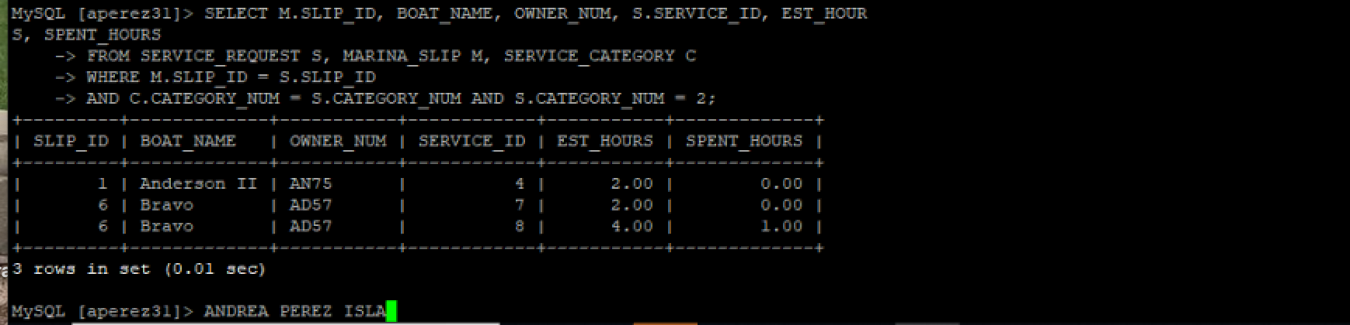

7. List the boat name, owner number, owner last name, and owner first name for each boat in marina 1.

SELECT M.BOAT_NAME, O.OWNER_NUM, LAST_NAME, FIRST_NAME  
FROM MARINA_SLIP M,OWNER O  
WHERE M.OWNER_NUM = O.OWNER_NUM AND MARINA_NUM=1;

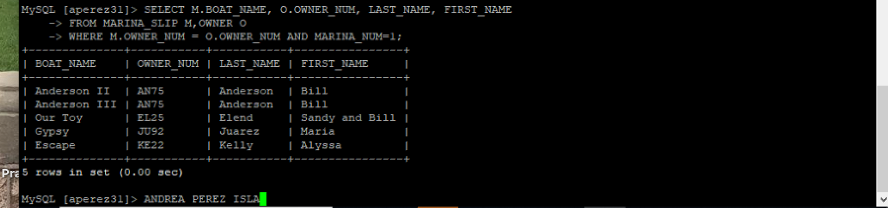

8. Repeat Exercise 7, but this time only list boats in 30-foot slips.

SELECT M.BOAT_NAME, O.OWNER_NUM, LAST_NAME, FIRST_NAME  
FROM MARINA_SLIP M,OWNER O  
WHERE M.OWNER_NUM = O.OWNER_NUM AND LENGTH = '30' AND MARINA_NUM=1;

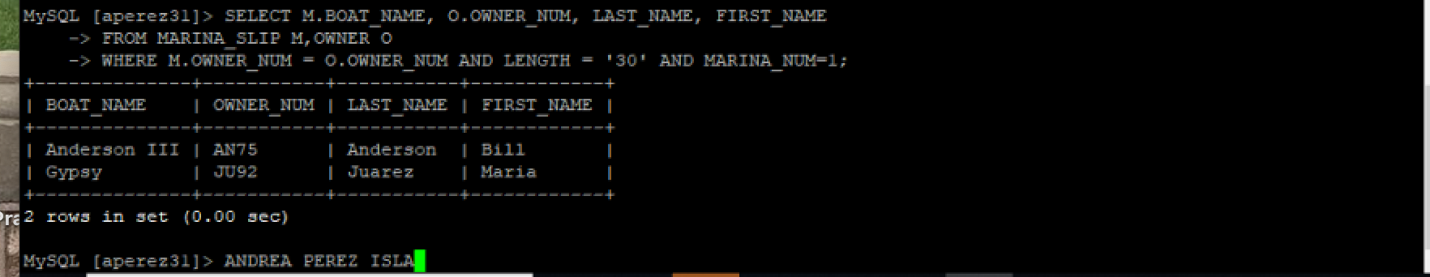

10. List the marina number, slip number, and boat name for boats whose owners live in Glander Bay and whose type is Sprite 4000.

SELECT m.MARINA_NUM, m.SLIP_NUM, m.BOAT_NAME

FROM MARINA_SLIP m

JOIN OWNER o

ON m.OWNER_NUM = o.OWNER_NUM

WHERE o.CITY = 'Glander Bay'

AND m.BOAT_TYPE=’Sprite 4000’;



9. List the marina number, slip number, and boat name for boats whose owners live in Glander Bay or whose type is Sprite 4000.

SELECT MARINA_NUM,SLIP_ID,BOAT_NAME FROM MARINA_SLIP WHERE OWNER_NUM IN (SELECT OWNER_NUM FROM OWNER WHERE CITY=’Glander Bay’) UNION SELECT MARINA_NUM,SLIP_ID,BOAT_NAME FROM MARINA_SLIP WHERE BOAT_TYPE=’Sprite 4000’;



11. List the marina number, slip number, and boat name for boats whose owners live in Glander Bay but whose type is not Sprite 4000.

SELECT m.MARINA_NUM, m.SLIP_NUM, m.BOAT_NAME

FROM MARINA_SLIP m

JOIN OWNER o

ON m.OWNER_NUM = o.OWNER_NUM

WHERE o.CITY = 'Glander Bay'

AND m.BOAT_TYPE<>’Sprite 4000’;

